
 | WM 1: Display Storage Bin
Exercise Display a storage bin. Time 5 min
Task Use the SAP Easy Access Menu to display a storage bin.
A storage bin is the smallest addressable unit in a warehouse. It identifies the exact location in the warehouse where goods can be stored. It can be further sub-divided into bin sections.  Several different materials (quants) can be stored in one bin at the same time. A quant is used to identify a material stock of a particular category in a storage bin. |  | Storage bin
To display a storage bin, follow the menu path:  Logistics ► Logistics Execution ► Internal Whse Processes ► Bins and Stock ► Display ► Single Display ► Storage Bin |  | Menu path
In the Display Storage Bin Screen, enter 100 as Warehouse No. and 001 (Shelf Storage) as Storage Type. Then, use the F4 help to select one of your storage bins. To do so select the field Storage bin and press F4. |  | 100  001  F4
Enter *### as Storage Bin (replace ### with your number). Now you should see the following screen. |  | *###
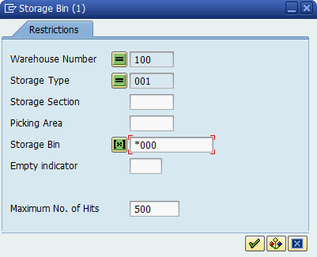
Then, click on . On the next screen, select any of the entries with a double click.
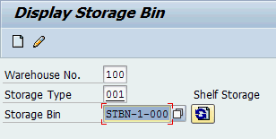
Press Enter to confirm your entries and to refresh the screen. This displays detailed information about the storage bin you selected.
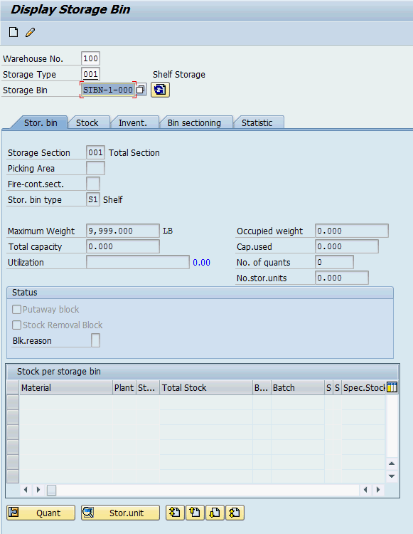
Click on the exit icon to return to the SAP Easy Access screen.

 | WM 2: Run Bin Status Report
Exercise Run a bin status report. Time 10 min
Task Use the Easy Access Menu to run a bin status report and take a look at all bins within the warehouse.
The Bin Status Report provides current information on the status of your bins. You can use this report for an overview of all your bins or to have a look at bins with a specific good in them. |  | Bin status report
To run a bin status report, follow the menu path:  Logistics ► Logistics Execution ► Internal Whse Processes ► Bins and Stock ► Display ► Bin Status Report |  | Menu path
In the Bin Status Report: Initial Screen, use the F4 help to select the San Diego Warehouse as Warehouse number. Make sure that all other search criteria fields are blank and click on . |  | F4  100
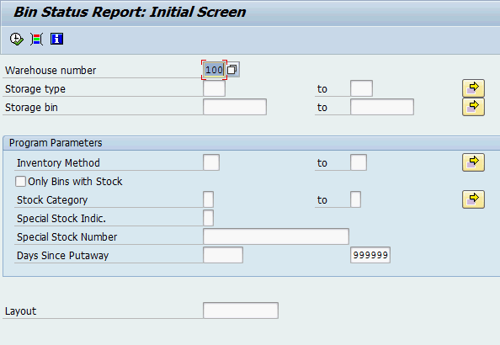
Now you can see a list of all the bins within this warehouse. They are following all the same numbering schema. The table also displays the storage type of each individual bin
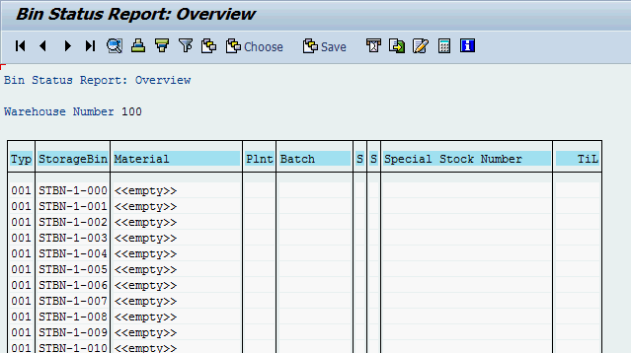
An unfiltered report can contain a lot of bins. Thus, you would like to see your bins only. Because all of your bins end with your number (###), you are able to filter the report. To do so, return to the Bin Status Report: Initial Screen by clicking on .
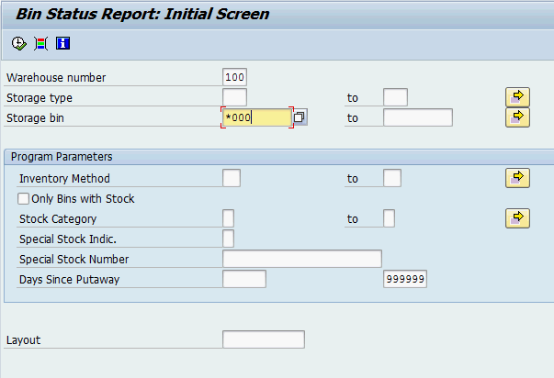
Fill in 100 as Warehouse number and *### as Storage bin (replace ### with your number). Then, click on . |  | 100  *###
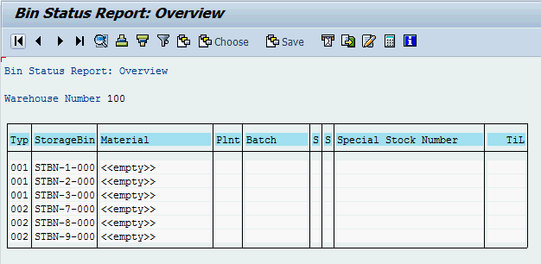
Note: Your bin report might look different dependent whether or not you have already processed a Warehouse Management case study.
If you click on one of the StorageBin entries in the list, you will get the same information screen as in exercise WM 1.
By clicking on one of the Material entries in the list, you will get an information screen, containing detailed information about the quant.
Click on the exit icon to return to the SAP Easy Access screen.

